Hospital Management System using MySQL

ID :
NAME :
COLLEGE :
GITHUB URL :

Table Schema
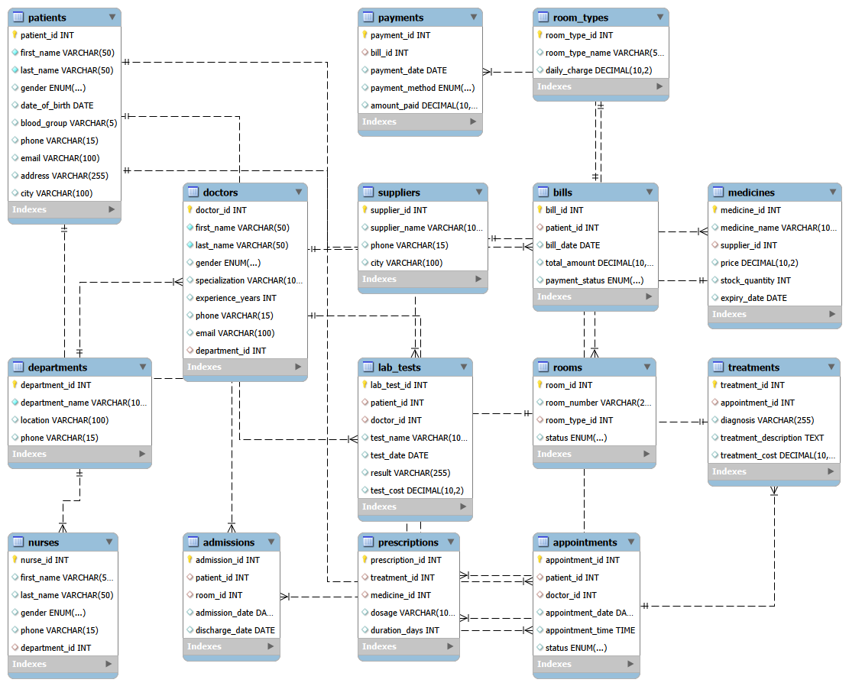
PROJECT OBJECTIVE :
The main objective of this project is to design and implement a Hospital Management System database using MySQL. The system efficiently manages hospital operations including patient records, doctor details, appointments, admissions, treatments, medicines, laboratory tests, billing, payments, room allocation, suppliers, and staff information. The database minimizes redundancy, maintains data integrity using primary and foreign keys, and enables efficient retrieval of information through SQL queries.

BASIC LEVEL QUESTIONS :
-- Q1. Retrieve all records from the Patients table.
SELECT * FROM patients;

-- Q2. Display all doctor records.
SELECT * FROM doctors;

-- Q3. Display all department details.
SELECT * FROM departments;

-- Q4. Retrieve all medicine details.
SELECT * FROM medicines;

-- Q5. Display all male patients.
SELECT *
FROM patients
WHERE gender = 'Male';

-- Q6. Display doctors who have more than 10 years of experience.
SELECT *
FROM doctors
WHERE experience_years > 10;

-- Q7. Display all available rooms.
SELECT *
FROM rooms
WHERE status = 'Available';

-- Q8. Retrieve all paid bills.
SELECT *
FROM bills
WHERE payment_status = 'Paid';

-- Q9. Display doctors ordered by experience in descending order.
SELECT *
FROM doctors
ORDER BY experience_years DESC;

-- Q10. Display the first 10 patient records.
SELECT *
FROM patients
LIMIT 10;

-- Q11. Count the total number of patients.
SELECT COUNT(*) AS TotalPatients
FROM patients;

-- Q12. Count the total number of doctors.
SELECT COUNT(*) AS TotalDoctors
FROM doctors;

-- Q13. Display all distinct patient cities.
SELECT DISTINCT city
FROM patients;

-- Q14. Display medicines costing more than ₹500.
SELECT *
FROM medicines
WHERE price > 500;

-- Q15. Display all appointments scheduled in the year 2025.
SELECT *
FROM appointments
WHERE appointment_date BETWEEN '2025-01-01' AND '2025-12-31';

-- Q16. Display the details of the ICU room type.
SELECT *
FROM room_types
WHERE room_type_name = 'ICU';

-- Q17. Display patients with blood group O+.
SELECT *
FROM patients
WHERE blood_group = 'O+';

-- Q18. Retrieve all pending bills.
SELECT *
FROM bills
WHERE payment_status = 'Pending';

-- Q19. Display medicines with stock quantity less than 200.
SELECT *
FROM medicines
WHERE stock_quantity < 200;

-- Q20. Display lab tests with a Positive result.
SELECT *
FROM lab_tests
WHERE result = 'Positive';

INTERMEDIATE LEVEL QUESTIONS :

-- Q21. Display each doctor's name along with their department name.
SELECT
d.first_name,
d.last_name,
dp.department_name
FROM doctors d
JOIN departments dp
ON d.department_id = dp.department_id;

-- Q22. Display room numbers along with their room type and daily charge.
SELECT
r.room_number,
rt.room_type_name,
rt.daily_charge
FROM rooms r
JOIN room_types rt
ON r.room_type_id = rt.room_type_id;

-- Q23. Display patient names with their appointment dates and appointment status.
SELECT
p.first_name,
p.last_name,
a.appointment_date,
a.status
FROM patients p
JOIN appointments a
ON p.patient_id = a.patient_id;

-- Q24. Display patient names, doctor names, and appointment dates.
SELECT
p.first_name,
p.last_name,
CONCAT(d.first_name,' ',d.last_name) AS Doctor_Name,
a.appointment_date
FROM appointments a
JOIN patients p
ON a.patient_id = p.patient_id
JOIN doctors d
ON a.doctor_id = d.doctor_id;

-- Q25. Count the number of doctors in each department.
SELECT
dp.department_name,
COUNT(d.doctor_id) AS Total_Doctors
FROM departments dp
LEFT JOIN doctors d
ON dp.department_id = d.department_id
GROUP BY dp.department_name;

-- Q26. Count the number of bills based on payment status.
SELECT
payment_status,
COUNT(*) AS Total_Bills
FROM bills
GROUP BY payment_status;

-- Q27. Display the total number of patients in each city.
SELECT
city,
COUNT(*) AS Total_Patients
FROM patients
GROUP BY city
ORDER BY Total_Patients DESC;

-- Q28. Count the number of patients in each blood group.
SELECT
blood_group,
COUNT(*) AS Total_Patients
FROM patients
GROUP BY blood_group;

-- Q29. Count the number of rooms based on room status.
SELECT
status,
COUNT(*) AS Total_Rooms
FROM rooms
GROUP BY status;

-- Q30. Count the number of medicines supplied by each supplier.
SELECT
s.supplier_name,
COUNT(m.medicine_id) AS Total_Medicines
FROM suppliers s
LEFT JOIN medicines m
ON s.supplier_id = m.supplier_id
GROUP BY s.supplier_name;

-- Q31. Find the average treatment cost.
SELECT
AVG(treatment_cost) AS Average_Treatment_Cost
FROM treatments;

-- Q32. Find the highest bill amount.
SELECT
MAX(total_amount) AS Highest_Bill
FROM bills;

-- Q33. Find the lowest medicine price.
SELECT
MIN(price) AS Lowest_Medicine_Price
FROM medicines;

-- Q34. Calculate the total payment amount received.
SELECT
SUM(amount_paid) AS Total_Payment_Received
FROM payments;

-- Q35. Count the number of appointments handled by each doctor.
SELECT
CONCAT(d.first_name,' ',d.last_name) AS Doctor_Name,
COUNT(a.appointment_id) AS Total_Appointments
FROM doctors d
LEFT JOIN appointments a
ON d.doctor_id = a.doctor_id
GROUP BY d.doctor_id, Doctor_Name
ORDER BY Total_Appointments DESC;

-- Q36. Display patients who have attended more than one appointment.
SELECT
p.patient_id,
CONCAT(p.first_name,' ',p.last_name) AS Patient_Name,
COUNT(a.appointment_id) AS Total_Visits
FROM patients p
JOIN appointments a
ON p.patient_id = a.patient_id
GROUP BY p.patient_id, Patient_Name
HAVING COUNT(a.appointment_id) > 1;

-- Q37. Find the average experience of doctors in each department.
SELECT
dp.department_name,
AVG(d.experience_years) AS Average_Experience
FROM departments dp
JOIN doctors d
ON dp.department_id = d.department_id
GROUP BY dp.department_name;

-- Q38. Count the number of rooms available for each room type.
SELECT
rt.room_type_name,
COUNT(r.room_id) AS Total_Rooms
FROM room_types rt
LEFT JOIN rooms r
ON rt.room_type_id = r.room_type_id
GROUP BY rt.room_type_name;

-- Q39. Count the number of lab tests based on test results.
SELECT
result,
COUNT(*) AS Total_Tests
FROM lab_tests
GROUP BY result;

-- Q40. Calculate the total amount collected through each payment method.
SELECT
payment_method,
SUM(amount_paid) AS Total_Collection
FROM payments
GROUP BY payment_method;

ADVANCED LEVEL QUESTIONS :
-- Q41. Display each patient along with the total number of appointments they have booked.
SELECT
p.patient_id,
CONCAT(p.first_name,' ',p.last_name) AS Patient_Name,
COUNT(a.appointment_id) AS Total_Appointments
FROM patients p
LEFT JOIN appointments a
ON p.patient_id = a.patient_id
GROUP BY p.patient_id, Patient_Name
ORDER BY Total_Appointments DESC;

-- Q42. Display each department with the total number of doctors working in it.
SELECT
dp.department_name,
COUNT(d.doctor_id) AS Total_Doctors
FROM departments dp
LEFT JOIN doctors d
ON dp.department_id = d.department_id
GROUP BY dp.department_name;

-- Q43. Display all bills whose amount is greater than the average bill amount.
SELECT *
FROM bills
WHERE total_amount >
(
SELECT AVG(total_amount)
FROM bills
);

-- Q44. Display the doctor(s) having the highest years of experience.
SELECT
first_name,
last_name,
experience_years
FROM doctors
WHERE experience_years =
(
SELECT MAX(experience_years)
FROM doctors
);

-- Q45. Categorize bills as High, Medium, or Low using the CASE statement based on the bill amount.
SELECT
bill_id,
total_amount,
CASE
WHEN total_amount >= 30000 THEN 'High Bill'
WHEN total_amount >= 15000 THEN 'Medium Bill'
ELSE 'Low Bill'
END AS Bill_Category
FROM bills;

-- Q46. Rank doctors based on their years of experience using the RANK() window function.
SELECT
doctor_id,
first_name,
experience_years,
RANK() OVER
(
ORDER BY experience_years DESC
) AS Experience_Rank
FROM doctors;

-- Q47. Assign row numbers to patients within each city using the ROW_NUMBER() window function.
SELECT
patient_id,
first_name,
city,
ROW_NUMBER() OVER
(
PARTITION BY city
ORDER BY patient_id
) AS Row_Num
FROM patients;

-- Q48. Use a Common Table Expression (CTE) to display the total number of doctors in each department.
WITH DepartmentDoctorCount AS
(
SELECT
department_id,
COUNT(*) AS Total_Doctors
FROM doctors
GROUP BY department_id
)
SELECT *
FROM DepartmentDoctorCount;

-- Q49. Create a VIEW to display each patient along with their total number of appointments.
CREATE VIEW PatientAppointmentSummary AS
SELECT
p.patient_id,
CONCAT(p.first_name,' ',p.last_name) AS Patient_Name,
COUNT(a.appointment_id) AS Total_Appointments
FROM patients p
LEFT JOIN appointments a
ON p.patient_id = a.patient_id
GROUP BY
p.patient_id,
Patient_Name;

-- Q50. Create a VIEW to display doctor details along with their department name and years of experience.
CREATE VIEW DoctorDepartmentSummary AS
SELECT
d.doctor_id,
CONCAT(d.first_name,' ',d.last_name) AS Doctor_Name,
dp.department_name,
d.experience_years
FROM doctors d
JOIN departments dp
ON d.department_id = dp.department_id;

